**JAVAIRIA REHMAN**

**19P-0020**

**BS(CS) 19-6A**

**“WEB PROGRAMMING”**

**ASSIGNMENT 1**

**Outputs**

**Question 1**

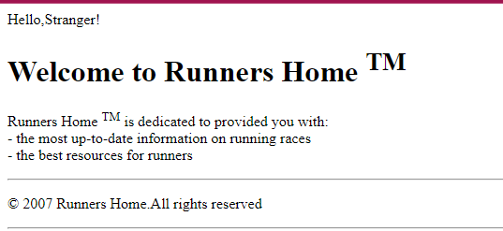

**Question 2**

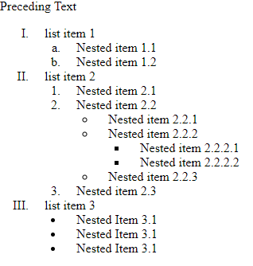

**Question 3**

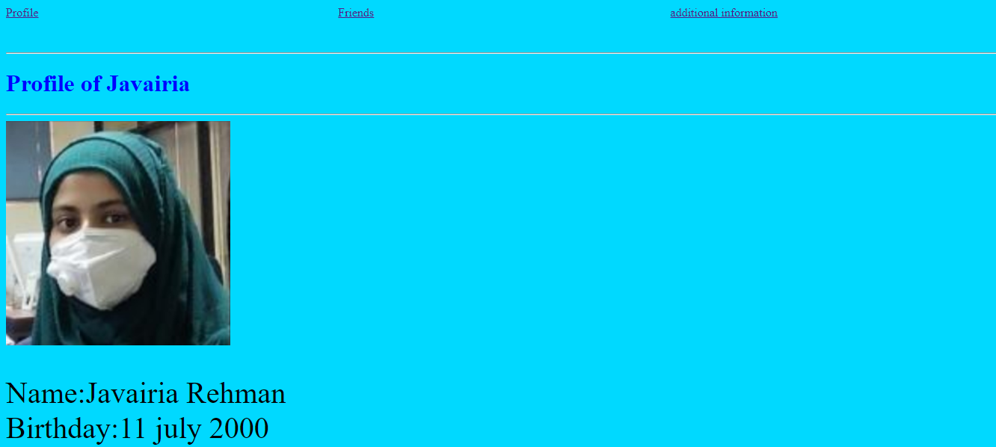



**Question 4**

